**Department of Italian Studies Spring 2021**

**ITAL 110, Elementary Italian I  
Staff**A beginning course with extensive practice in speaking, reading, writing, and listening and a thorough introduction to Italian grammar. Activities include group and pairs work, role-playing, and conversation. Introduction to Italian culture through readings and films.

Conducted in Italian. Enrollment limited to 12.

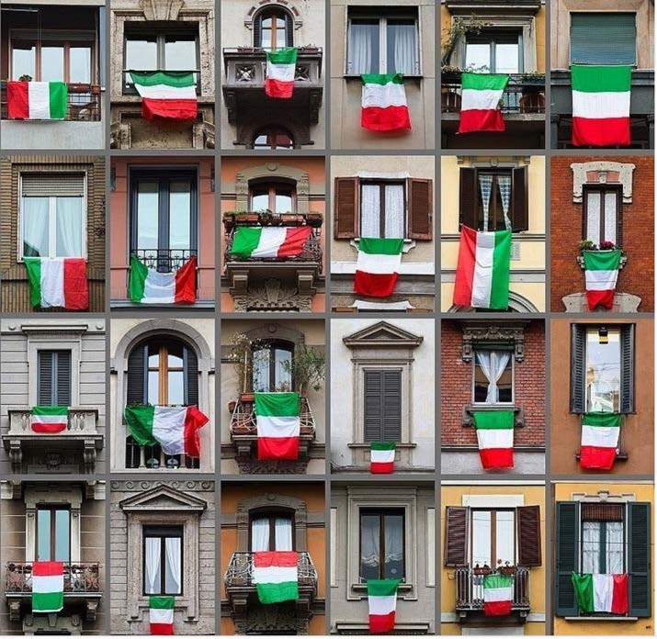**ITAL 120, Elementary Italian II**   
**C. Barchiesi, G. Berchi, S. Lorenzini, D. Pellegrino**  
Continuation of ITAL 110. Enrollment limited to 12.

**ITAL 125, Intensive Elementary Italian**  
**Michael Farina** **M-F9.25-11.15a**  
An accelerated beginning course in Italian that covers in one term the material taught in two.

**ITAL 140, Intermediate Italian II**   
**Anna Iacovella M-F 10.30-11.20a**   
Continuation of ITAL 130. Emphasis on advanced discussion of Italian culture through authentic readings (short stories, poetry, and comic theater) and contemporary films. Admits to Group B courses.

Conducted in Italian. Enrollment limited to 12. Prerequisite: ITAL 130 or equivalent.

|  |
| --- |
| Image result for italian images*Group B courses are conducted in Italian and are open to students who have passed ITAL 140 or 145 and to others with the consent of the director of undergraduate studies and of the instructor.*  **ITAL 151, Advanced Italian Workshop: Reading and Translating Contemporary Italian Poetry,  Sandro-Angelo De Thomasis MW 11.35-12.50** Our journey begins in the early 90s, in the wake of the fall of the “First Republic” (1948-1993), by contextualizing the socio-political situation of Italy at this important historical juncture. We then proceed to reading avant-garde and experimental poetry from the edgy “Gruppo ’93” and move forward until today, listening and deciphering hip-hop artists such as Ghali and Bello FiGo, and exploring questions of appropriation, linguistics, identity, and more. By the end of this class, you will have read, analyzed, and translated several poems from contemporary Italy. Moreover, by being exposed to translation theory and critical analysis, you will also have developed your own philosophy of translation as well as critical skills related to language use in both English and Italian. Furthermore, you will have acquired a deeper and better understanding of the last 30 years of Italian history.  Prerequisite: [ITAL 140](https://courses.yale.edu/search/?p=ITAL%20140) or equivalent. |

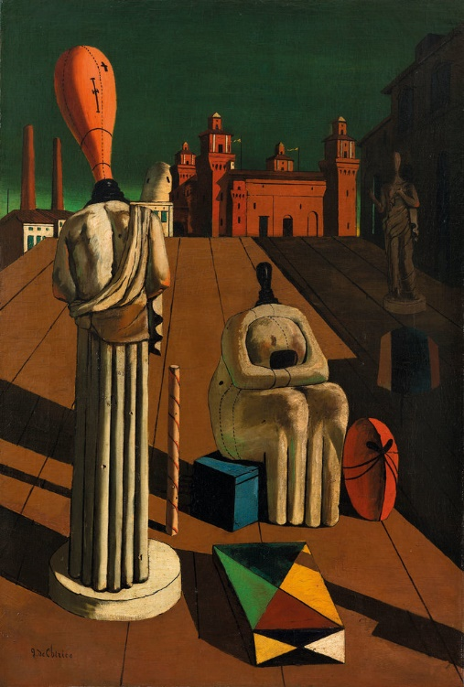**ITAL 172, Introduction to Italian Literature: From the Baroque to the Present**  **Simona Lorenzini MW 2.30–3.45p**  
  
This course is the second course in a sequence studying Italian Literature. This course introduces students to the masterpieces of Italian literature, in prose and poetry, from the Baroque to the 21st century. We closely read sample writings representative of the most important authors and literary movements, including Galileo, Manzoni, Pirandello, and Ferrante, and the ways in which they encompassed science, medicine, culture, law, gender. Through critical readings, textual analysis, and class discussions, students appreciate the intellectual and artistic traditions that shaped the birth of the Italian nation. Texts and authors are examined in their historical, social, and cultural context. The course is conducted in Italian. Students are required to take notes during the lectures and learn new vocabulary specific to the topic studied. Prerequisite: [ITAL 140](https://courses.yale.edu/search/?p=ITAL%20140) or equivalent.

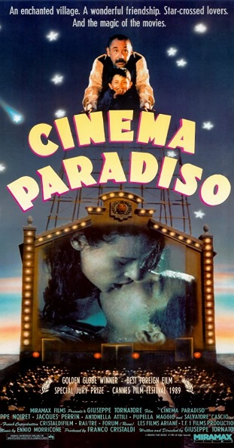*Group C courses are conducted in English and are open to students without previous study of Italian. Majors in Italian are required to read the material and write their papers in Italian.*

**ITAL 303, Italian Film from Postwar to Postmodern**   
**Millicent Marcus T TH 4 -5.15p**  
A study of important Italian films from World War II to the present. Consideration of works that typify major directors and trends. Topics include neorealism, self-reflexivity and metacinema, fascism and war, and postmodernism. Films by Fellini, Antonioni, Rossellini, De Sica, Visconti, Pasolini, Bertolucci, Wertmuller, Tornatore, and Moretti.   
Films in Italian with English subtitles.

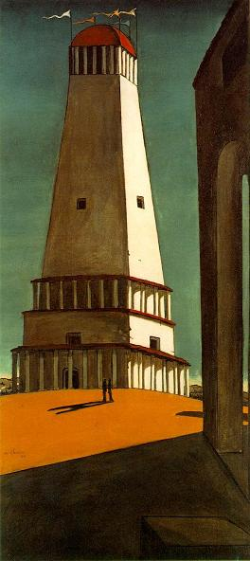**Ital 305, Nostaglia Epidemic and Cure  
Megan Crognale MW 11.35-12.50p**   
Nostalgia goes by many names: *saudade, mal du pays, Heimweh*, to list a few. Though the term was coined in 1688 as a medical diagnosis for homesickness, it has since come to fundamentally shape the way that we imagine our past, present, and future. Often described as a longing for a different time or a simpler past, nostalgia has inspired artists, authors, composers, filmmakers, and thinkers to create masterpieces of longing and imagined worlds. In the realm of politics, on the other hand, nationalist parties have harnessed the sentiment to commit acts of extreme violence. Many contemporary thinkers have classified modern nostalgia as an epidemic to be feared or avoided at all costs. Today, we are witnessing the intensification of politics of nostalgia, which itself has a long history. This course explores that history, and asks the question: if we are all already nostalgic, how can we use our nostalgia for productive, rather than destructive, ends? We consider many facets of nostalgia, both positive and negative, including its close connection with memory, desire, identity, the nation, and even the modern categories of time and space. Sophomore Seminar: Registration preference given to sophomores. Not normally open to first-year students.  
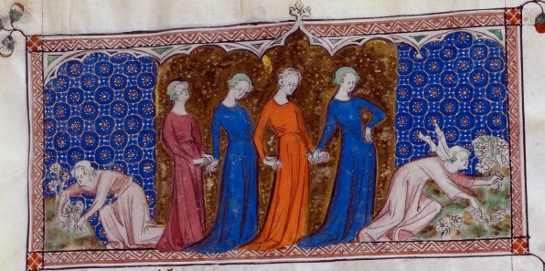

**ITAL 317b, HUMS210, LITR 180, WGSS 317 Women in the Middle** **Ages**

**Christiana Purdy Moudarres T TH 1 -2.15p**  
Medieval understandings of womanhood examined through analysis of writings by and/or about women, from antiquity through the Middle Ages. Introduction to the premodern Western canon and assessment of the role that women played in its construction.

**ITAL322, USA: Travelers, Immigrants, Exiles from Italy (1920-2001)   
Giuseppe Mazzotta/Megan Crognale T TH 11.35-12.50p**

From 1870 to 1924, as many as 5 million Italian immigrants crossed the Atlantic to seek their fortunes in the United States. Most of them were Southern Italian peasants who thought their journey was a temporary means of supporting their families, but few returned to il bel paese. Instead, Italian Americans gradually ascended the socio-economic ladder, going from day laborers to middle class workers over the span of a few generations. The course focuses on their experiences as told through a variety of media: from novel and short stories to music and films. Its goal is to promote a critical historical consciousness of the social, political, and cultural reality of the Italian presence in the United States from the end of the First World War to the beginning of the twenty-first century. In addition to Italian American works, students will encounter Italian literature and film in order to investigate the roots of Italian American culture and to investigate the driving factors behind Southern Italian immigration.

**Ital 335, Fascism, Pop Culture and Everyday Life: Belonging and Excluding from Fascist Italy to the Present, Serena Bassi W 3.30-5.20p**

The word “fascism” makes us think of a top-down ideology that celebrates homogeneity, conformity, and the cult of the leader. Yet, today’s far right subcultures like the Alt-Right present themselves as subversive grassroots movements making use of the internet’s democratising power to stand up against what they see as “liberal groupthink.” This course invites you to rethink fascism as a bottom-up process of identity formation as we examine the relationship between popular culture, modern leisure and the far-right throughout the twentieth century and in our own political moment. How are violent racist and sexist ideologies circulated through seemingly innocent leisure practices? What role have popular culture and everyday free time activities like watching sports, shopping and reading bestselling fiction historically played in fascist mobilizations? Why was the then emergent mass media so important to European fascist states and how did they write cultural policy? Finally, may we speak of a Euro-American fascist cultural imagination that spans the 20th and the 21st centuries? If so, what can we learn about the persistence of fascist ideas today when we choose to focus on the cultural politics of reception, consumption, belonging and exclusion?

